INTEGRATED ELECTRONICS

**Submitted To: ENGR. SHIRAZ AFZAL**

ELECTRONIC ENGINEERING DEPARTMENT

INTEGRATED ELECTRONICS

GARAGE DOOR OPENING SYSTEM



**Submitted By:**

**MUHAMMAD HASSAN 2017-EE-069**

**AAZIB AHMED ANSARI 2017-EE-078**

**MIRZA HAMZA UMER 2017-EE-079**

**MUHAMMAD USMAN 2017-EE-107**

**GARAGE DOOR OPENING SYSTEM**

**INTEGRATED ELECTRONICS (EE_322)**

**Submitted by**

**MUHAMMAD HASSAN 2017-EE-069 AAZIB AHMED ANSARI 2017-EE-078**

**MIRZA HAMZA UMER 2017-EE-079**

**MUAMMAD USMAN 2017-EE-107**

**6th Semester Project Report**

Department of Electronic Engineering

Sir Syed University Of Engineering and Technology, Karachi

**ACKNOWLEDGEMENT**

We would like to express our deepest appreciation to all those who provided us the possibility to complete this project and report.  A special gratitude we give to our project  teacher, Engr. Shiraz Afzal & ENGR. Jawwad Bhatti, whose contribution in stimulating suggestions and encouragement,  helped us to coordinate our project & especially in writing this report.

Furthermore we would also like to acknowledge with much appreciation the crucial role of Sir Shahrukh who gave the guidance to in our project and the necessary materials to complete the project. A special thanks goes to my Group Members who help me to assemble the parts and gave suggestion about the task .Last but not least, many thanks go to the head of the project, whose have invested his full effort in guiding the team in achieving the goal. I have to appreciate the guidance given by other supervisor as well as the panels especially in our project presentation that has improved our presentation skills thanks to their comment and advices.

**TABLE OF CONTENTS**

**Page**

**Acknowledgment** 02

**Table of Contents** 03

**List of Figures & Tables**  04

**Abstract** 05

1. **INTRODUCTION**

1.1 Introduction 05

1. **WORKING**

2.1 Working Criteria  05

2.2 Function of the Circuit 06

1. **PROJECT CIRCUIT DIAGRAM**

3.1 Circuit Diagram(Layout) 06

3.2 Truth Table 07

3.3 Timming Diagram 07

1. **METHODOLOGY**

4.1 Source code 08

1. **SYSTEM SOFTWARE** 09

1. **CONCLUSION** 09

**LIST OF FIGURES**

**Page**

Figure 2.1 Circuit Diagram of Project 05

Figure 3.1 Circuit Layout 06

Figure 3.3Timimng Diagram 07

**LIST OF TABLES**

**Page**

Table 2.2 Function of the Circuit 06

Table 3.2 Truth Table 07

**ABSTRACT**

In this project we have propose a system of working of door of a garage system using the Verilog to code the program and used microwind to have the layout designed, as it can be implemented on a chip to perform that specific task accordingly to the desire of a user of that IC or door system.

**INTRODUCTION**

* 1. **Introduction:**

A garage door system is designed in this project. To code this program Verilog software is used in gate level modelling . Microwind software is used to have a layout of that code so it can be implemented as when it required. For this project a motor is required to deploy the working of the circuit. Three input keys are used named as Activate, press-up and press-down key.Activate key is just like a system on/off swith and press up key will work to raise the garage gate and press down key is used lower the garage gate.

**WORKING**

**2.1 Working criteria:**

In this project we have made a garage door opening system using the Verilog and microwind software in this we have implemented an activate key which will work as a ON/OFF switch, further that we have made 5 more buttons named as **Activate, Inside_up_button,** **Outside_up_button**, **Inside_down_button** and **Outside_down_button** which will drive the motor whenever 1 is given to it. The circuit is basically depend on two end gates having one input common in both(Activate key). The working setup is explained by the help of the following given table.

**motor-up = Activate * (Inside_up_button + Outside_up_button)**

**motor-down = Activate * (Inside_down_button + Outside_down_button)**

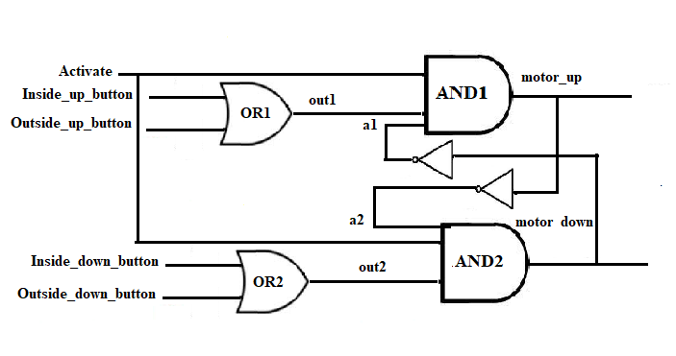 **FIGURE: 2.1 CIRCUIT DIAGRAM OF GARAGE SYSTEM**

**2.2 FUNCTION OF THE CIRCUIT:**

|  |  |  |
| --- | --- | --- |
| **NAME** | **TYPE** | **FUNCTION** |
| **ACTIVATE** | **INPUT** | Starts the door to go up or down according to the given input. |
| **Inside-up_button** | **INPUT** | Indicates to up the door from inside the door. |
| **Inside-down_button** | **INPUT** | Indicates to down the door from inside the door. |
| **Outside-up_button** | **INPUT** | Indicates to up the door from outside the door. |
| **Outside-down_button** | **INPUT** | Indicates to down the door from outside the door. |
| **MOTOR-UP** | **OUTPUT** | Causes motor to run in direction to raise the door. |
| **MOTOR-DOWN** | **OUTPUT** | Causes motor to run in direction to lower the door. |

**PROJECT CIRCUIT DIAGRAM**

* 1. 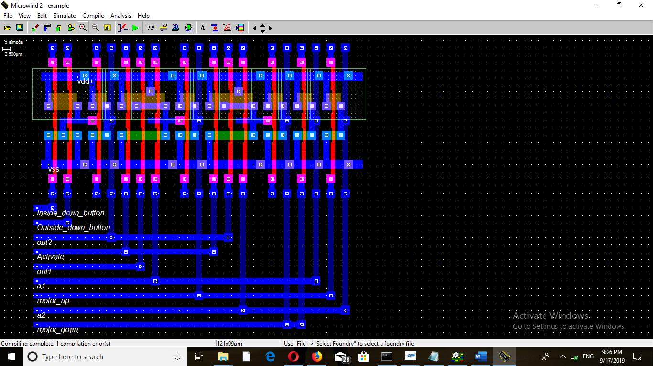 **CIRCIUT Diagram(LAYOUT):**

**Figure 3.1 CIRCUIT DIAGRAM OF THE PROJECT**

* 1. **SIMULATION TIMING DIAGRAM(MICROWIND):**

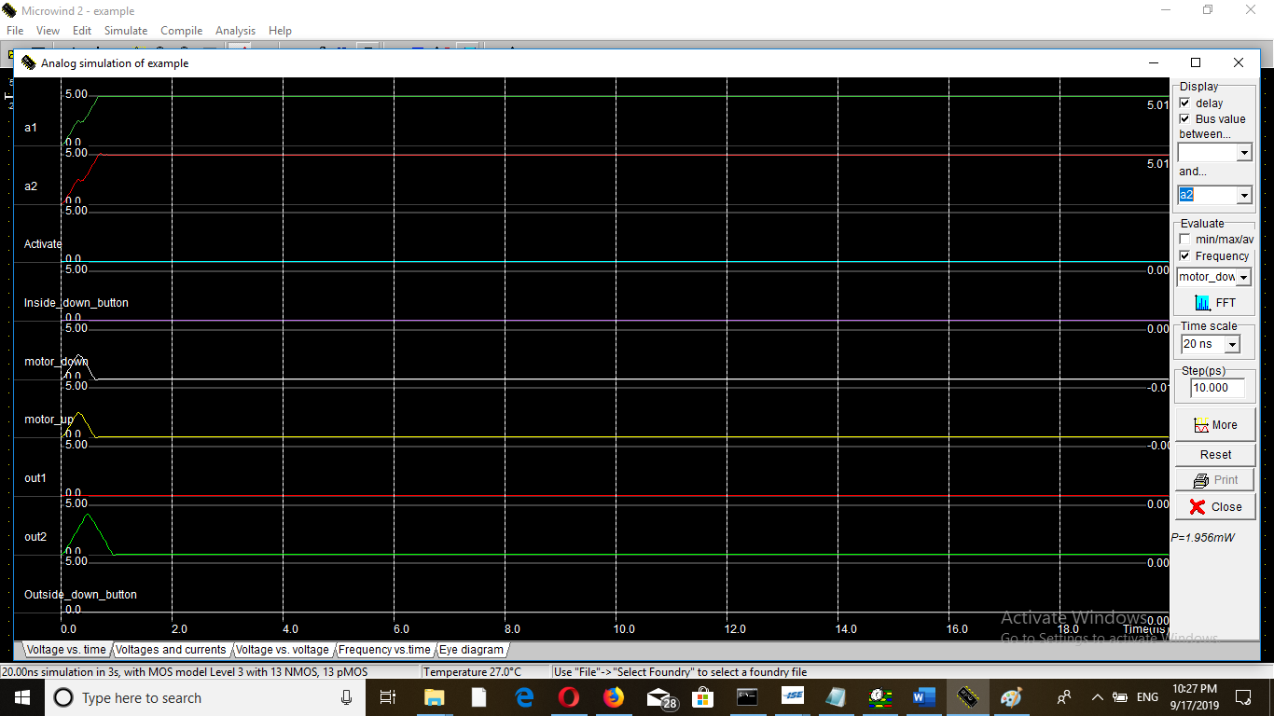

**3.3 TRUTH TABLE:**

|  |  |  |  |  |  |  |
| --- | --- | --- | --- | --- | --- | --- |
| **INPUT** | | | | | **OUTPUT** | |
| **Activate** | **Inside_up_**  **button** | **Outside_up_**  **button** | **Inside_down_**  **button** | **Outside_down_**  **button** | **motor_**  **up** | **motor_**  **down** |
| **1** | **0** | **0** | **0** | **0** | **0** | **0** |
| **1** | **1** | **0** | **0** | **0** | **1** | **0** |
| **1** | **0** | **0** | **0** | **1** | **0** | **1** |
| **1** | **0** | **1** | **0** | **0** | **1** | **0** |
| **1** | **0** | **0** | **1** | **0** | **0** | **1** |
| **0** | **0** | **0** | **0** | **0** | **0** | **0** |

* 1. 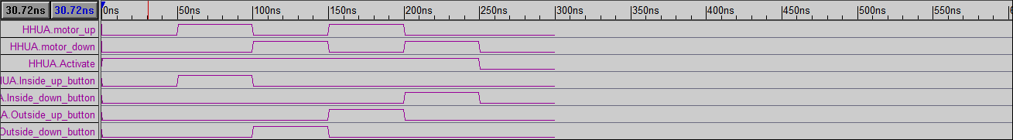 **CIRCUIT TIMMING DIAGRAM**

**METHODOLOGY**

* 1. **SOURCE CODE: (VERILOG)**

//Design Module

module Garage_Door_System(motor_up,motor_down,Activate,Inside_up_button,Inside_down_button,Outside_up_button,Outside_down_button);

input Activate,Inside_up_button,Inside_down_button,Outside_up_button,Outside_down_button;

output motor_up,motor_down;

wire out1,out2,a1,a2;

or o1(out1,Inside_up_button,Outside_up_button);

or o2(out2,Inside_down_button,Outside_down_button);

and an1(motor_up,Activate,out1,a1);

and an2(motor_down,Activate,out2,a2);

not n1(a1,motor_down);

not n2(a2,motor_up);

endmodule

//Stimullux Module

module HHUA;

reg Activate,Inside_up_button,Inside_down_button,Outside_up_button,Outside_down_button;

wire motor_up,motor_down;

Garage_Door_System g1(motor_up,motor_down,Activate,Inside_up_button,Inside_down_button,Outside_up_button,Outside_down_button);

initial

begin

Activate=1'b1; Inside_up_button=1'b0; Outside_up_button=1'b0; Inside_down_button=1'b0; Outside_down_button=1'b0;

#50

Activate=1'b1; Inside_up_button=1'b1; Outside_up_button=1'b0; Inside_down_button=1'b0; Outside_down_button=1'b0;

#50

Activate=1'b1; Inside_up_button=1'b0; Outside_up_button=1'b0; Inside_down_button=1'b0; Outside_down_button=1'b1;

#50

Activate=1'b1; Inside_up_button=1'b0; Outside_up_button=1'b1; Inside_down_button=1'b0; Outside_down_button=1'b0;

#50

Activate=1'b1; Inside_up_button=1'b0; Outside_up_button=1'b0; Inside_down_button=1'b1; Outside_down_button=1'b0;

#50

Activate=1'b0; Inside_up_button=1'b0; Outside_up_button=1'b0; Inside_down_button=1'b0; Outside_down_button=1'b0;

#50

$finish;

end

endmodule

**SYSTEM SOFTWARE**

**4.1 SOFTWARE:**

1. **Verilogger Pro:**

Hardware description languages such as Verilog are similar to [software](https://en.wikipedia.org/wiki/Software) [programming languages](https://en.wikipedia.org/wiki/Programming_language) because they include ways of describing the propagation time and signal strengths (sensitivity). Like C, Verilog is [case-sensitive](https://en.wikipedia.org/wiki/Case-sensitive).

1. **MicroWind:**

MICROWIND is truly integrated EDA software encompassing IC designs from concept to completion, enabling chip designers to design beyond their imagination. MICROWIND integrates traditionally separated front-end and back-end chip design into one flow, accelerating the design cycle and reduces design complexities.

It tightly integrates mixed-signal implementation with digital implementation, circuit simulation, transistor-level extraction and verification – providing an innovative education initiative to help individuals to develop the skills needed for design positions in virtually every domain of IC industry.

**Conclusion**

* 1. **Conclusion:**

In this project we have proposed a code for a garage door using Verilog to code the program and to design layout we used microwind. The circuit is basically depend on two end gates having one input common in both(Activate key).